SIMATS ENGINEERING
Pasam.Murali Krishna
(192525178)

ASSESSMENT TOOL 1

COURSE NAME: Database Management Systems COURSE CODE: CSA05

COURSE OUTCOME COVERED

CO1: Analyze DBMS architecture, different data models, schema types, and design ER/EER diagrams, relational schemas for case-based scenarios by identifying entities and relationships. (BL1, BL2)

Activity Tool : Short Answer Text(High) Assessment Tool Weightage: 30%

Dr

QUESTIONS |  | Total Marks: 50
Q.No | Question | Bloom's Level | Marks
1 | UPS Product Tracking Information System | BL1 – | 5
 |  | Remember
 | UPS prides itself on having up-to-date information on the processing and current location of each shipped item. To do this, UPS relies on a company-wide information system. Shipped items are the heart of the UPS product tracking information system. Shipped items can be characterized by item number (unique), weight, dimensions, insurance amount, destination, and final delivery date. Shipped items are received into the UPS system at a single retail center. Retail centers are characterized by their type, uniqueID, and address. Shipped items make their way to their destination via one or more standard UPS transportation events (i.e., flights, truck deliveries). These transportation events are characterized by a unique scheduleNumber, a type (e.g, flight, truck), and a deliveryRoute. Create an Entity Relationship diagram that captures this

 | information about the UPS system.
2 | Course Management System  Consider a university database for the scheduling of classrooms for final exams. This database could be modeled as the single entity set exam, with attributes course-name, section-number, room-number, and time. Alternatively, one or more additional entity sets could be defined, along with relationship sets to replace some of the attributes of the exam entity set, as  - course with attributes name, department, and c-number  - section with attributes s-number and enrollment, and dependent as a weak entity set on course  - room with attributes r-number, capacity, and building Show an E-R diagram illustrating the use of all three additional entity sets listed. | BL2 –  Understand | 5
3 | University Registrar’s Office Management System  A university registrar’s office maintains data about the following entities:  - courses, including number, title, credits, syllabus, and prerequisites;  - course offerings, including course number, year, semester, section number, instructor(s), timings, and classroom;  - students, including student-id, name, and program;  - instructors, including identification number, name, department, and title.  - Further, the enrollment of students in courses and grades awarded to students in each course they are enrolled for must be appropriately modeled.  Construct an E-R diagram for the registrar’s  office. | BL2 –  Understand | 5
4 | Hospital Management System  Construct an E-R diagram for a hospital with a set of patients and a set of medical doctors.  Associate with each patient a log of the various tests | BL2 –  Understand | 5

and examinations conducted. Construct appropriate tables for the above ER Diagram :
Patient(SS#, name, insurance) Physician ( name, specialization) Test-log( SS#, test-name, date, time) Doctor-patient (physician-name, SS#) Patient-history(SS#, test-name, date)
5 | Company Project Management System  Construct an ER Diagram for Company having following details :  Company organized into DEPARTMENT. Each department has unique name and a particular employee who manages the department. Start date for the manager is recorded. Department may have several locations.  A department controls a number of PROJECT. Projects have a unique name, number and a single location.  Company’s EMPLOYEE name, ssno, address, salary, sex and birth date are recorded. An employee is assigned to one department, but may work for several projects (not necessarily controlled by dept). Number of hours/week an employee works on each project is recorded; The immediate supervisor for the employee.  Employee’s DEPENDENT are tracked for health insurance purposes (dependentname, birthdate, relationship to employee). | BL2 –  Understand | 5
6 | Explain schema and instance with examples. Distinguish between logical schema, physical schema, and view schema. | BL1 –  Remember | 5
7 | Identify the entities, attributes, and relationships for a Bank Management System and construct its ER diagram. | BL2 –  Understand | 5
8 | Explain the Extended ER (EER) model. Describe the concepts of generalization, specialization, and aggregation. | BL2 –  Understand | 5
9 | Design an EER diagram for a Hospital Management | BL2 – | 5

 | System incorporating inheritance and weak entities. | Understand
10 | Explain the role of a DBA (Database Administrator) and the responsibilities associated with the position. | BL1 –  Remember | 5

Code of Conduct:

I P.Murali Krishna(192525178) certify that this submission is my original work and that I have adhered to the guidelines specified for this assessment. I understand that any violation of academic integrity rules will result in disciplinary action.

Signature of the student: 

RUBRICS FOR CALCULATION:

Criteria | Weightage | Level 4 (Exemplary) | Level 3 (Proficient) | Level 2 (Developing) | Level 1 (Beginning)
Concept Identification | 30% | Demonstrates clear and complete understanding of the concept | Good understanding with minor gaps | Basic understanding with some misconceptions | Poor or incorrect understandin g
Linkages | 25% | Completely correct answer with no errors | Mostly correct with minor errors | Partially correct with noticeable errors | Incorrect or irrelevant answer
Organization | 20% | Correctly applies concepts to solve  the question/problem | Applies concepts with minor mistakes | Limited or partially correct application | No or incorrect application
Integration of Literature | 15% | Covers all required parts of the question | Covers most parts with minor omissions | Covers only some parts | Incomplete or missing response
Clarity | 10% | Clear, concise, and well- | Understandabl e with minor | Somewhat unclear or | Difficult to understand

 |  | organized answer | issues | poorly structured

Q1. UPS Product Tracking Information System (5 Marks)
Create an Entity Relationship diagram that captures the information about the UPS system.

Entities & Attributes
- ShippedItem: ItemNumber (PK), Weight, Dimensions, InsuranceAmount, Destination, FinalDeliveryDate
- RetailCenter: UniqueID (PK), Type, Address
- TransportationEvent: ScheduleNumber (PK), Type (flight/truck), DeliveryRoute

Relationships
- RECEIVED_AT: ShippedItem (N) → RetailCenter (1)
- TRANSPORTED_VIA: ShippedItem (N) ↔ TransportationEvent (M)
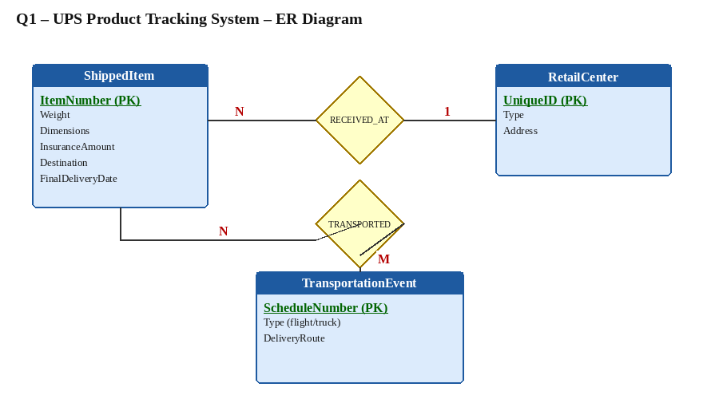
Figure 1: ER Diagram – UPS Product Tracking System

Q2. Course Management System – Final Exam Scheduling
Show an E-R diagram illustrating the use of Course, Section (weak entity) and Room.

Entities & Relationships
- Course: Name, Department, C-Number (PK)
- Section (Weak Entity): S-Number (partial key), Enrollment – depends on Course
- Room: R-Number (PK), Capacity, Building
- SEC_OF (Identifying): Course (1) → Section (N)
- SCHEDULED_IN: Section (N) → Room (1) with attribute Time
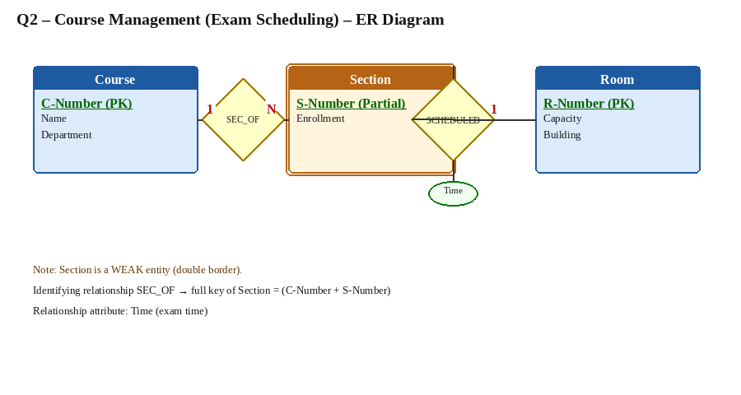
Figure 2: ER Diagram – Course / Section (Weak) / Room

Q3. University Registrar’s Office Management System
Construct an E-R diagram for the registrar’s office.

Entities
- Course – CourseNumber (PK), Title, Credits, Syllabus
- CourseOffering – Year, Semester, SectionNumber, Timings, Classroom
- Student – StudentID (PK), Name, Program
- Instructor – IDNumber (PK), Name, Department, Title

Relationships
- PREREQUISITE – recursive on Course (N:M)
- OFFERS – Course (1) → CourseOffering (N)
- TEACHES – Instructor (N) ↔ CourseOffering (M)
- ENROLLS – Student (N) ↔ CourseOffering (M) with attribute Grade
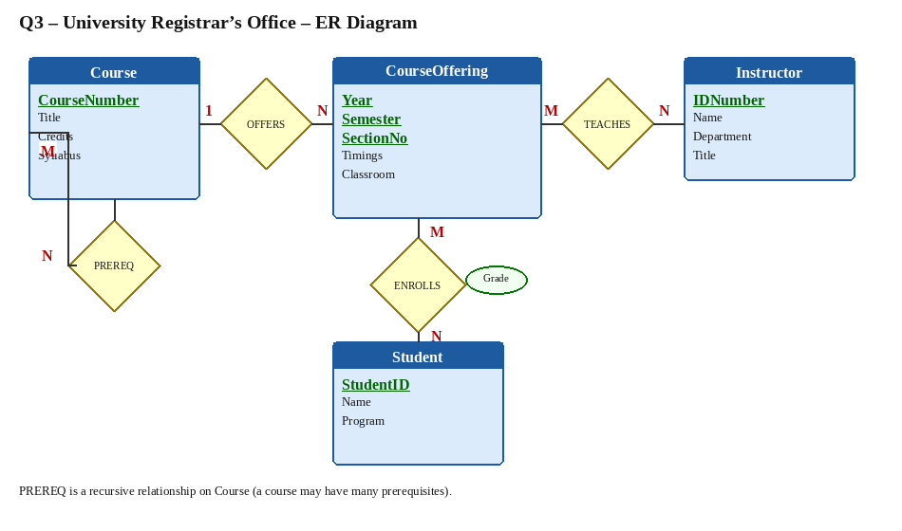
Figure 3: ER Diagram – University Registrar’s Office

Q4. Hospital Management System (5 Marks)
Construct an E-R diagram for a hospital with patients and medical doctors. Associate test logs and construct tables.

Entities & Relationships
- Patient – SS# (PK), Name, Insurance
- Physician – Name (PK), Specialization
- Test-Log (Weak) – SS#, TestName, Date, Time
- TREATS – Physician (N) ↔ Patient (M)
- UNDERGOES – Patient (1) → Test-Log (N)
Tables: Patient(SS#, name, insurance); Physician(name, specialization); Test-log(SS#, test-name, date, time); Doctor-patient(physician-name, SS#); Patient-history(SS#, test-name, date)
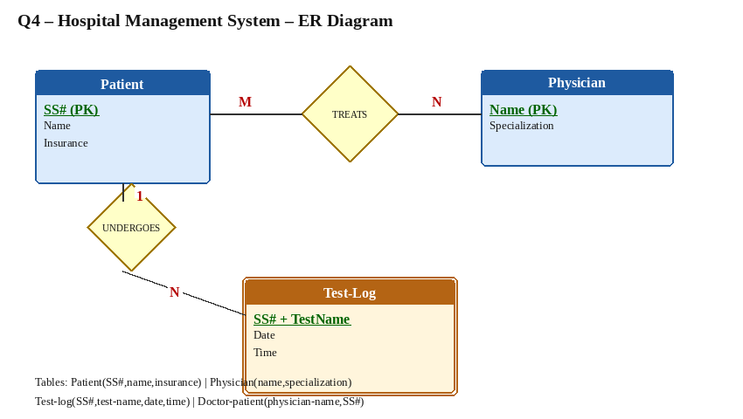
Figure 4: ER Diagram – Hospital Management System

Q5. Company Project Management System (5 Marks)
Construct an ER Diagram for Company with Departments, Projects, Employees and Dependents.

Entities
- EMPLOYEE – SSN (PK), Name, Address, Salary, Sex, BirthDate
- DEPARTMENT – DName (PK), DNumber, Locations (multi-valued)
- PROJECT – PNumber (PK), PName, Location
- DEPENDENT (Weak) – DependentName (partial), BirthDate, Relationship

Relationships
- WORKS_FOR – Employee (N) → Department (1)
- MANAGES – Employee (1) → Department (1) with StartDate
- CONTROLS – Department (1) → Project (N)
- WORKS_ON – Employee (N) ↔ Project (M) with Hours
- SUPERVISION – recursive Employee (1) → Employee (N)
- DEPENDENTS_OF (Identifying) – Employee (1) → Dependent (N)
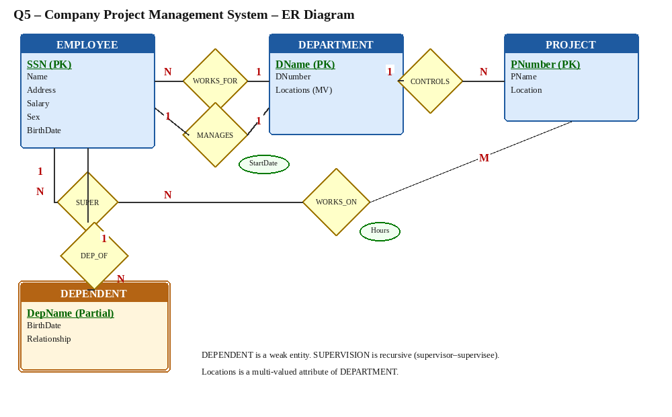
Figure 5: ER Diagram – Company Project Management System

Q6. Schema and Instance
Explain schema and instance with examples. Distinguish between logical schema, physical schema, and view schema.

Schema
A schema is the overall design / structure of the database. It describes entities, attributes, relationships and constraints. It changes infrequently (intention of the database).
Example: Student(RollNo, Name, Branch, Year) – this structure is the schema.

Instance
An instance is the actual data present in the database at a particular point in time. It changes frequently (extension of the database).
Example: Rows (101, “Ravi”, “CSE”, 2), (102, “Priya”, “ECE”, 3) form the current instance.

Three Levels of Schema
- Logical (Conceptual) Schema: Describes the entire database for the organization – entities, relationships, constraints. Hides physical storage details.
- Physical (Internal) Schema: Describes how data is stored on disk – file organization, indexes, page sizes, clustering.
- View (External) Schema: Different views for different user groups showing only relevant data (e.g., Faculty view vs Admin view).

Q7. Bank Management System
Identify the entities, attributes, and relationships for a Bank Management System and construct its ER diagram.

Entities
- Customer – CustomerID (PK), Name, Address, Phone, DOB, Email
- Account – AccountNumber (PK), AccountType, Balance, OpenDate, Status
- Branch – BranchID (PK), BranchName, Address, IFSC, Phone
- Loan – LoanID (PK), LoanType, Amount, InterestRate, Tenure
- Transaction – TransactionID (PK), Type, Amount, DateTime, Mode

Relationships
- HOLDS – Customer (N) ↔ Account (M)
- BELONGS_TO – Account (N) → Branch (1)
- AVAILS – Customer (N) ↔ Loan (M)
- ISSUED_BY – Loan (N) → Branch (1)
- PERFORMS – Account (1) → Transaction (N)
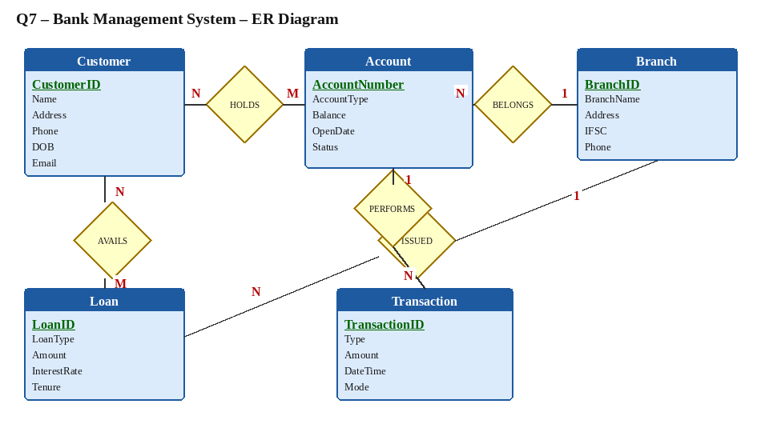
Figure 6: ER Diagram – Bank Management System

Q8. Extended ER (EER) Model
Explain the Extended ER (EER) model. Describe generalization, specialization, and aggregation.

Extended ER (EER) Model
The EER model extends the basic ER model with additional semantic concepts for more accurate modeling of complex real-world situations. Main constructs: specialization/generalization, aggregation, and categorization (union types).

1. Specialization
Top-down process of defining subclasses of a superclass. Subclasses inherit all attributes and relationships of the superclass and may have additional specific attributes.
Example: EMPLOYEE specialized into SECRETARY, ENGINEER, TECHNICIAN.

2. Generalization
Bottom-up reverse of specialization. Several entity types with common attributes are generalized into a higher-level superclass.
Example: CAR and TRUCK generalized into VEHICLE.

3. Aggregation
Abstraction that treats a relationship set as a higher-level entity set so that it can participate in other relationships. Used to model relationships among relationships.
Example: WORKS_ON (Employee–Project) aggregated and then related to a MANAGER via MANAGES.

Q9. EER Diagram for Hospital Management System
Design an EER diagram for a Hospital Management System incorporating inheritance and weak entities.

Inheritance (Specialization)
- PERSON (superclass) – PersonID, Name, Address, Phone, DOB
- PATIENT (subclass) – PatientID, BloodGroup, Insurance
- DOCTOR (subclass) – DoctorID, Specialization, LicenseNo
- STAFF (subclass) – StaffID, Role, Shift

Weak Entity & Relationships
- TEST (Weak Entity of PATIENT) – TestName (partial key), Date, Time, Result
- TREATS – Doctor (N) ↔ Patient (M)
- UNDERGOES (Identifying) – Patient (1) → Test (N)
- ADMITTED_TO – Patient (N) → Ward (1)
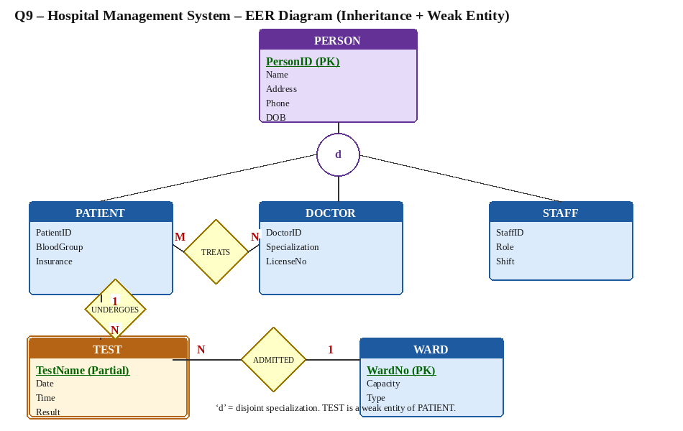
Figure 7: EER Diagram – Hospital (Inheritance + Weak Entity)

Q10. Role of a Database Administrator (DBA) (5 Marks)
Explain the role of a DBA and the responsibilities associated with the position.

Role of a DBA
A Database Administrator is responsible for the overall control, management, maintenance and security of a database system. The DBA ensures the database is available, reliable, secure and performs efficiently for all users.

Key Responsibilities
- Schema Definition: Creates and maintains conceptual, logical and physical schemas.
- Storage & Access Methods: Chooses file organizations, indexes and clustering for performance.
- Security & Authorization: Grants/revokes privileges, implements authentication and access control.
- Backup & Recovery: Plans regular backups and defines recovery procedures for failures.
- Integrity Constraints: Enforces entity, referential and domain integrity rules.
- Performance Tuning: Monitors queries, tunes SQL, optimizes indexes and buffers.
- User Support: Assists developers and end-users; provides documentation and training.
- Change Management: Manages schema evolution, version control and data migration.

